**INTRODUCTION**

My topic is personalized invitation. First I did my empathy map an brainstorm before starting the project. After that I did canva website login and start the project.

PROBLEM DEFINITION AND DESIGN THINKING:

Empathy map

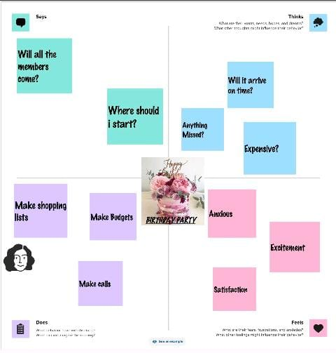

Ideation and brainstroming map

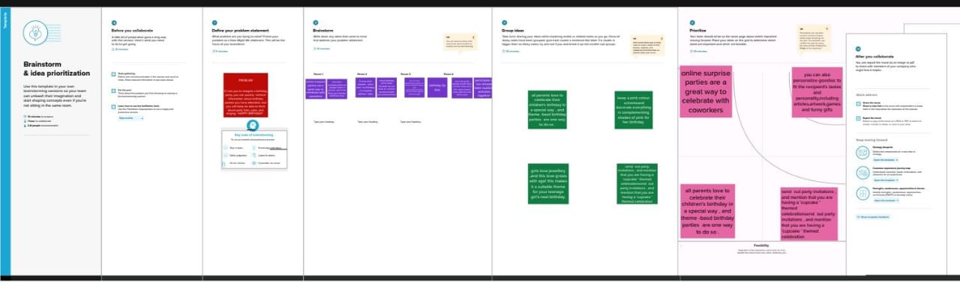

Result

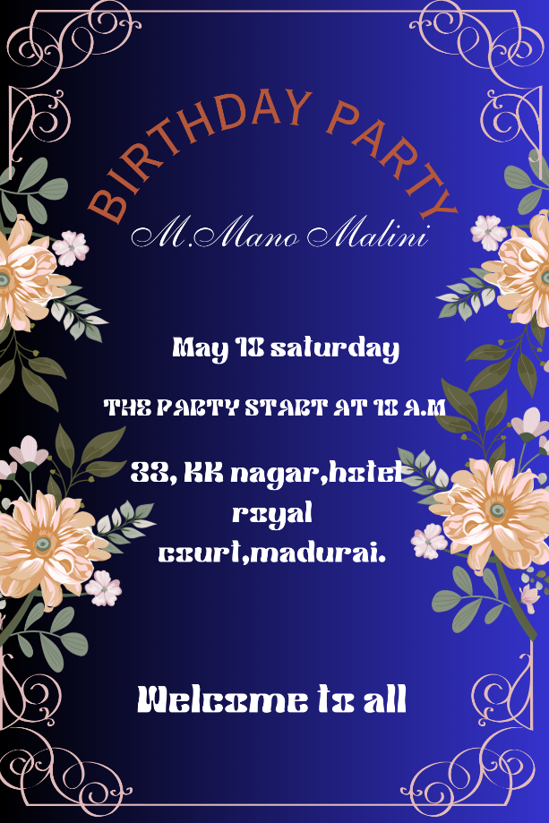

Advantages and disadvantages

* Advantage : The money that is saved when using online programs to send your birthday invitation cannot be denied. This can be easily savings of a hundred dollars for birthday person
* Disadvantage: Just us with the postal service there are sometimes instances in which an online invitation will get lost or will not be able to delivered.

APPLICATION:

I used laptop through canva website.

CONCLUSION:

Learned how to use canva laptop and then edit the design in my project